*EXCITING NEWS for FMLS Listing Agents!*

Syndication Remarks will replace Public Remarks on February 28th for various third party sites such as Zillow, Trulia and many others.

The purpose of Syndication Remarks is to provide the ability, for those brokerage companies who elect to syndicate their own listings, to self-promote the listing agent and the listing company to the public in their listings directly on Zillow, Trulia and various other third party sites! Read on to learn more about this change.

Increased Exposure for Listing Agents
To increase the exposure for listing agents on public internet portals, FMLS added the public-facing Syndication Remarks field on October 2nd. Since then as users have entered new listings, the Syndication Remarks field has automatically populated with the listing agent's name, preferred phone number and email address, as shown below:

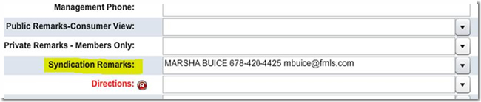

Members can then change or add more information about the features
of the subject property along with additional contact information.

The Syndication Remarks will be sent to the contracted syndicators, ListHub and eWebEngine, in lieu of the Public Remarks on all listings starting February 28th. These listings, in turn, are distributed to selected popular consumer search sites such as Trulia, Zillow and others, as designated by the broker.

What about IDX sites and Realtor.com®?
The Syndication Remarks will not be sent to IDX sites or Realtor.com®.

Self-Promotion is permitted?
Yes! Self-Promotion is permitted (AND encouraged!) in the Syndication Remarks field. This is the only remarks field where listing agents can include self-promotion. Members should feel free to enter names, phone numbers, website addresses, etc. as well as information about the property, open house information and neighborhood information. There are 575 characters available.

What if I want to use a portion of the remarks from the Public Remarks field?
You can enter whatever information you'd like into the Syndication Remarks. To save time, users may copy and paste a portion of the public remarks into the Syndication Remarks field.

Have questions? If you need further assistance, our FMLS Help Desk is ready to serve you via live chat, email or call us at 404-255-4219 and select option 1.

